Australia on the Move

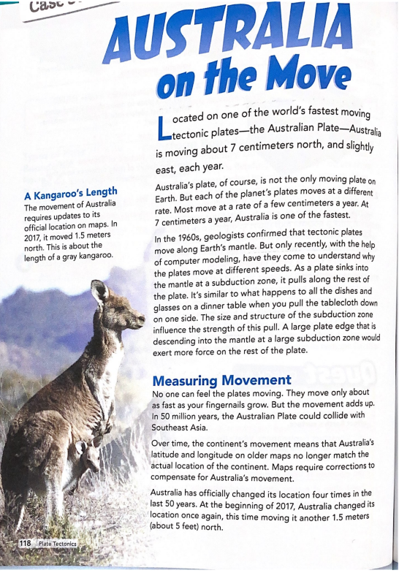

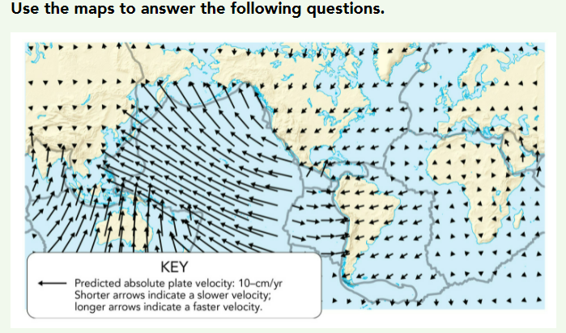

Write in complete sentences.

1. What factors affect the speed at which a tectonic plate moves? Other plates can affect the speed and since the plate sinks into the subduction zone it would affect the speed.
2. Which plate is moving fastest? Cite evidence to justify your answer. The Pacific Plate because it has other plates and subduction zones and pulls it down to the bottom so the Pacific plate would move the fastest.
3. Would you expect a largely oceanic plate to move faster than a largely continental plate? Explain your answer. Yes. It is because oceanic plates have areas like ridges and subduction zones pulling so the continental plate would be slower.
4. The Australian and Pacific Plates are among the fastest-moving plates. What conclusions can you make about the subduction zone where the Australian Plate meets the Pacific Plate? Use evidence from the text and the map to support your explanation. The Australian plate will pull the pacific plate into a subduction zone which will cause the plate to sink into the subduction zone. It will affect the Australian plate and the Indonesian islands by making them collide.